UTILITY BILL MANAGEMENT
@CREATIVITY THINK (9483175986/7019689991)

ABSTRACT:
Utility Bill Management is a web application designed to help users efficiently track, manage, and pay their utility bills. Users can add bills, receive automated payment reminders, download receipts, and access a dashboard displaying payment analytics. Administrators can manage users, categorize bills, send reminders, and export payment statistics for oversight. Built with Django and Django Rest Framework on the backend, and React, recharts, and axios on the frontend, this system centralizes bill management, simplifies payment tracking, and provides analytical insights for efficient utility oversight..

INTRODUCTION OF THE PROJECT:
Managing multiple utility bills manually can be time-consuming and prone to errors. Utility Bill Management provides a centralized platform where users can track bills, receive reminders, download receipts, and view analytics through a dashboard. Administrators can oversee user accounts, manage bill categories, and export reports to monitor payments. The backend handles authentication, bill processing, and API requests, while React provides an interactive interface with analytics charts. This platform ensures timely payments, reduces missed bills, and enhances administrative control over utility management..

PROJECT OBJECTIVES:

• Enable users to track and manage multiple utility bills
• Provide automated reminders for pending payments
• Allow receipt downloads and payment verification
• Offer a dashboard with visual analytics of bills and payments
• Enable administrators to manage users and bill categories
• Facilitate export of payment statistics for reporting
• Ensure secure handling of user data and bills
• Simplify utility management for residential and small office users

PROBLEM OF THE STATEMENT:
Users often struggle to keep track of multiple utility bills, leading to missed payments, late fees, and disorganized records. There is also limited visibility for administrators or managers overseeing multiple users or units. Utility Bill Management addresses these issues by providing a centralized system for tracking, reminders, receipt generation, and dashboard analytics. It improves payment timeliness, accountability, and management efficiency for both individual users and administrators..

MOTIVATION OF THE PROJECT:
• Reduce missed and late utility payments
• Centralize all bills and payment information in one platform
• Automate reminders to improve timeliness
• Provide downloadable receipts and records for users
• Offer administrative oversight through analytics and reports

BLOCK DAIGRAM OF PROJECT:

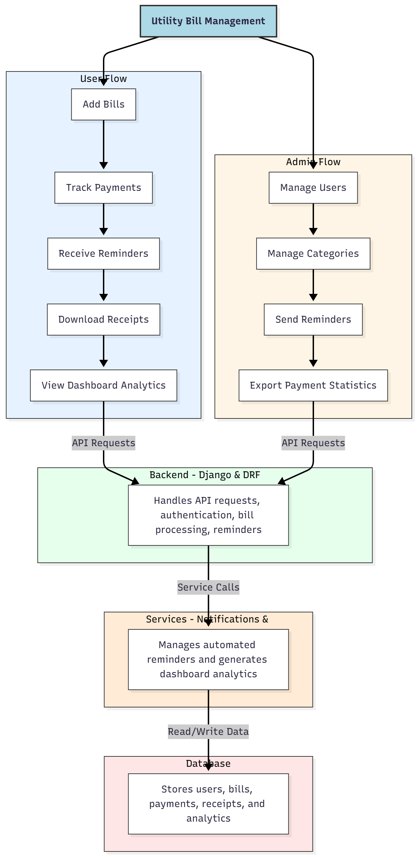

WORKING OF THE PROJECT:
Users can add utility bills, track payment status, receive automated reminders, download receipts, and monitor all payments via a dashboard. Administrators manage user accounts, categorize bills, send reminders, and export payment statistics. The backend handles API requests, authentication, and bill processing, while services manage notifications and analytics. The database stores users, bills, payments, receipts, and dashboard analytics. This system centralizes bill management, ensures timely payments, and provides comprehensive oversight for users and administrators..

SOFTWARE REQUIREMENT:
- Backend:
  - Python 3.x
  - Django
  - Django REST Framework
  - SQLite/PostgreSQL
- Frontend:
  - Node.js and npm
  - React.js
  - Axios
- Development Tools:
  - Visual Studio Code
  - Postman (for testing APIs)
  - Git/GitHub (for version control)
- Server/Deployment (Optional):
  - Gunicorn, Nginx, or Heroku/AWS for hosting

ADVANTAGES OF THE PROJECT:

• Centralizes bill tracking and management
• Provides automated payment reminders
• Offers downloadable receipts for record-keeping
• Displays payments and bills in dashboard analytics
• Allows administrators to manage users and categories
• Facilitates export of payment statistics
• Reduces missed payments and late fees
• Simplifies bill management for apartments, homes, and small offices

APPLICATIONS OF THE PROJECT:
• Residential apartments and housing societies
• Small office bill management
• Individual household utility tracking
• Automated reminder and payment notification system
• Payment and billing analytics dashboard
• Record-keeping with receipt downloads
• Administrative control for managers or landlords
• Integration with financial planning and accounting tools

REFERENCES:

- Django REST Framework Documentation — Django Software Foundation. Django Documentation. Available: https://docs.djangoproject.com/
- Django REST Framework. DRF Documentation. Available: https://www.django-rest-framework.org/
- React. React Official Documentation. Available: https://reactjs.org/docs/getting-started.html
- Redux. Redux Documentation. Available: https://redux.js.org/introduction/getting-started
- PostgreSQL Global Development Group. PostgreSQL Documentation. Available: https://www.postgresql.org/docs/
- MySQL. MySQL Reference Manual. Available: https://dev.mysql.com/doc/
- Git. Git Documentation. Available: https://git-scm.com/doc
- Node.js. Node.js Documentation. Available: https://nodejs.org/en/docs/
- Axios. Axios Documentation. Available: https://axios-http.com/docs/intro
- Socket.io Documentation – https://socket.io/docs/

